**Experiment No:** 11

**Experiment Name:** Introduction to Operators, Loops, and User-Defined Functions in JavaScript.

**Theory:**

**Operators:** Operators are used to perform different types of mathematical and logical computations.They come in handy while working with Conditional Statements and Loop.

**Conditional Statements:** JavaScript conditional statements allow to execution of specific blocks of code based on conditions. If the condition is met, a particular block of code will run; otherwise, another block of code will execute based on the condition.

**Loops:** Looping is essential for efficiently handling repetitive tasks. They execute a block of code repeatedly as long as a specified condition remains true. These loops are powerful tools for automating tasks and streamlining your code.

**Function:** In JavaScript, a function is a block of code that performs a task. It's defined using the function keyword, a name, and parentheses for parameters. The parameters (inputs) are specified within the parentheses, and the function body is enclosed in curly braces.

**Object:** In JavaScript, an object is allowed to store and organize data using key-value pairs. Each key is a string, and the associated value can be of any data type.

**Lab Task - 1:** Write a program to check if a given year is a leap year. The program should take an input year and print a message stating whether the year is a leap year or not.

**Source Code:**

**var year = prompt("Enter a year:");**

**year = parseInt(year);**

**var isLeap = false;**

**if (year % 4 === 0)**

**{**

**if (year % 100 !== 0 || year % 400 === 0)**

**{**

**isLeap = true;**

**}**

**}**

**if (isLeap)**

**{**

**console.log(year + " is a leap year.");**

**}**

**else**

**{**

**console.log(year + " is not a leap year.");**

**}**

**Output:**

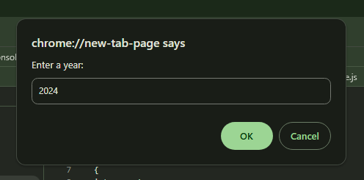

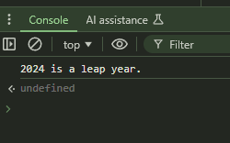

**Lab Task - 2:** Write a program that uses a for loop to print the multiplication table for a given number. Allow the user to input the number for which they want to see the multiplication table.

**Source Code:**

**var number = prompt("Enter a number:");**

**number = parseInt(number);**

**console.log("Multiplication Table for " + number + ":");**

**for (var i = 1; i <= 10; i++)**

**{**

**console.log(number + " x " + i + " = " + (number * i));**

**}**

**Output:**

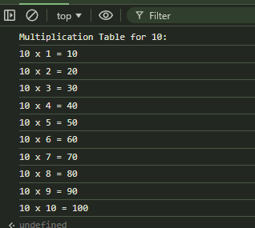

**Lab Task - 3:** Create a function called *‘calculateArea’* that takes the radius of a circle as an argument and returns the area.

**Source Code:**

**function calculateArea(radius)**

**{**

**var area = Math.PI * radius * radius;**

**return area;**

**}**

**var radius = prompt("Enter the radius of the circle:");**

**radius = parseFloat(radius); // Convert input to a floating-point number**

**var area = calculateArea(radius);**

**console.log("The area of the circle with radius " + radius + " is " + area);**

**Output:**

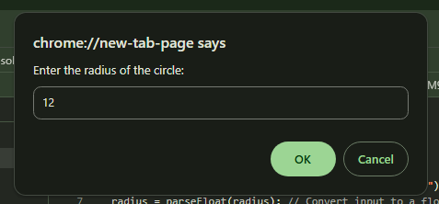

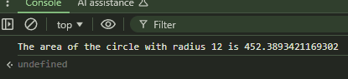

**Lab Task - 4:** Create an array of objects representing your departments. The object should have properties like departmentName, HOD (Head of Department), and an array of students. Again, each student object should include properties like name, studentID, and currentSemester.

**Source Code:**

**var departments = [**

**{ departmentName: "CCE",**

**HOD: "Prof:Raju",**

**students: [**

**{ name: "Maisha", studentID: "E241440", semester: 3 },**

**{ name: "Raisa", studentID: "E241440", semester: 2 }**

**]**

**},**

**{**

**departmentName: "CSE",**

**HOD: "Prof:Tohid",**

**students: [**

**{ name: "Nusrat", studentID: "CS241411", semester: 4 },**

**{ name: "Sara", studentID: "CS241417", semester: 1 }**

**]**

**},**

**{**

**departmentName: "ME",**

**HOD: "Prof:Rafiq",**

**students: [**

**{ name: "Alfi", studentID: "ME241401", semester: 5 },**

**{ name: "Shefu", studentID: "ME241402", semester: 3 }**

**]**

**}**

**];**

**console.log(departments);**

**Output:**

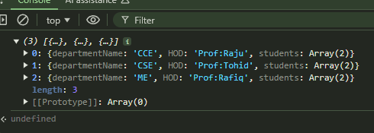

**Discussion:** In today’s lab report we got introduced about introduction to Operators, Loops, and User-Defined Functions in JavaScript.In this experiment, we delved into the fundamental concepts of JavaScript, focusing on operators, loops, and user-defined functions. Through hands-on practice, we gained a deeper understanding of how these essential components work together to create dynamic and interactive web applications. By integrating these concepts, we have laid a solid foundation for more advanced JavaScript programming. Mastering operators, loops, and functions equips us with the tools needed to tackle more complex problems and build robust web applications.